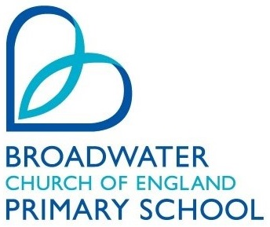
Broadwater Church of England Primary School
PRAYER LETTER
Autumn Term 2022

“For it is by grace you have been saved, through faith – and this is not from yourselves, it is the gift of God – not by works, to that no one can boast” Ephesians 2:8 &9

Prayer requests can be sent by email to the Governors (prayer@broadwaterce.org), sent to the school office or given to Governors at the Parent Consultation evenings. The prayer letters are issued towards the end of each term. We would value your contributions.

From our School Council

All children around the world having access to school and an education

New Year resolutions and to resolve any problems from the year

Families living in poverty and struggling with the cost of living

Making sure everyone has food, drink and a hot meal this Christmas

For there to be a peaceful resolution for the war in Ukraine

For All our School Community
Ephesians 4 v 32
“Be kind and compassionate to one another, forgiving each other, just as in Christ, God forgave you.”

We pray that we will keep in good health and spirits through the winter.
Loving Father,
Thank you for all who are part of Broadwater school. Please grant them your encouragement, wisdom and peace.

Christmas Prayer
Dear Father in Heaven,
Thank You for giving us the gift of Jesus, the greatest Christmas gift of all. Please help us to remember why we celebrate, even as we eat Christmas food and open presents. We are very thankful for the real reason for this celebration and, without Jesus, we wouldn’t have Christmas! We love You and thank You for giving us this day!
Amen.
A Selection of Prayers from Year 6

